CS4223: Multi-Core Architectures

A0294308Y LEE Seoung Sub

A0308849M Ryan Harwood

**Cache simulator**

**Language** : C++

**Implementation**

**-Basic CPU**

CPU class, which have cpu id, cache, bus, dram, cycles, etc..

**-Read line(from data files)**

Read label and data. Input of cpu execution

**-Cache access (if fail, mem access)**

Request data to cache if not, target cycles change for mem access

**-Bus access**

Not implemented yet.

**-Compute cycles**

Add cycles for an instruction to total cycles

**Input example**

Just “make” then “./coherence MESI blackscholes_ 1024 1 16”

**Output**

- Overall cycles

- Compute cycles

- # of Load/store

- Idle cycles

- Cache hit / miss

**Process**

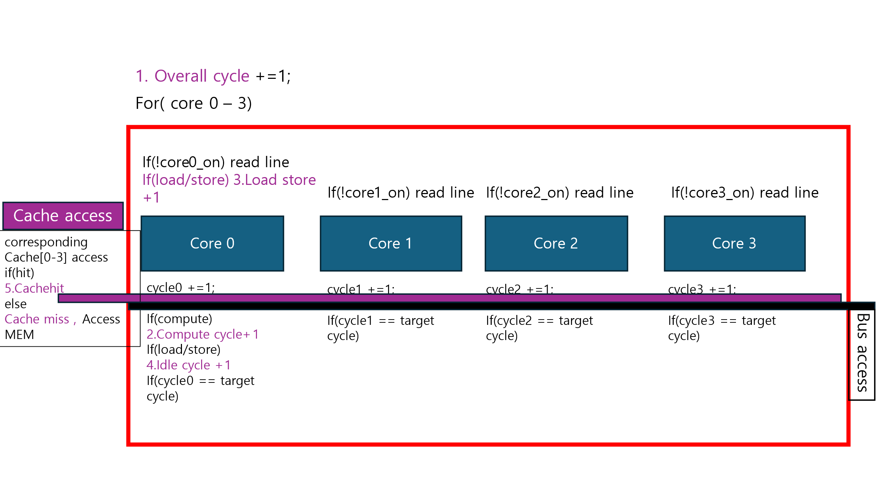

But we only implemented Single Core yet.

**Cycles datail**

